|  |
| --- |
| Department of Software Engineering  Mehran University of Engineering and Technology, Jamshoro |

|  |  |  |  |
| --- | --- | --- | --- |
| Course: SWE324 - Data Warehousing and Data Mining | | | |
| Instructor | Rabeea Jaffari | **Practical/Lab No.** | 04 |
| Date |  | **CLOs** | CLO-4: P3 & P4 |
| Signature |  | **Assessment Score** | 1 Mark |

|  |  |
| --- | --- |
| Topic | To familiar with OLTP system reporting |
| Objectives | * To learn report generation in OLTP systems |

|  |
| --- |
| Lab Discussion: Theoretical concepts and Procedural steps |

Generate an OLTP system report which displays the following results:

1. **Total sales in a month** (Use only order table).
2. **Profit/loss in a month** (Use product (to account for purchasing costs), expenditure as well as order tables).
3. **Highest selling product of the month**(By highest sold quantity)
4. **Lowest selling product of the month**(By lowest sold quantity)

**Expenditure:**

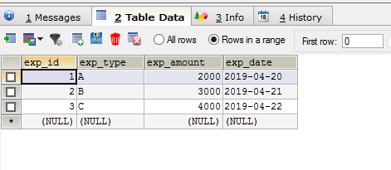

**Order_tab:**

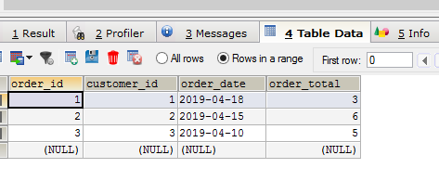

**Product:**

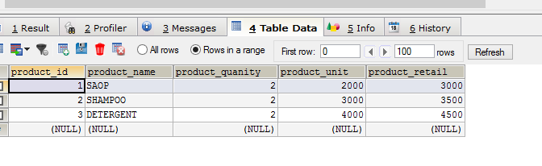

**Order_details:**

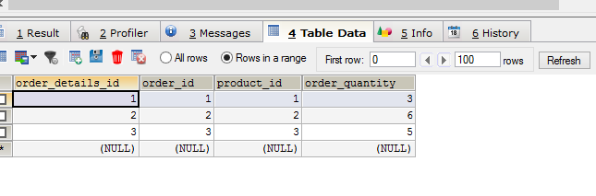

**Stored Procedure:**

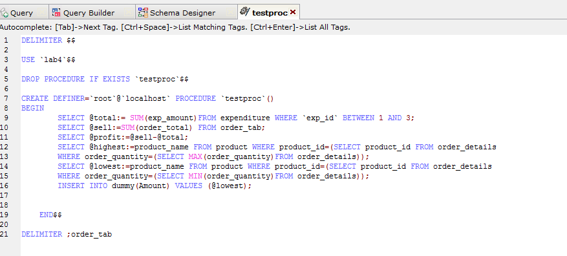

**Output:**

